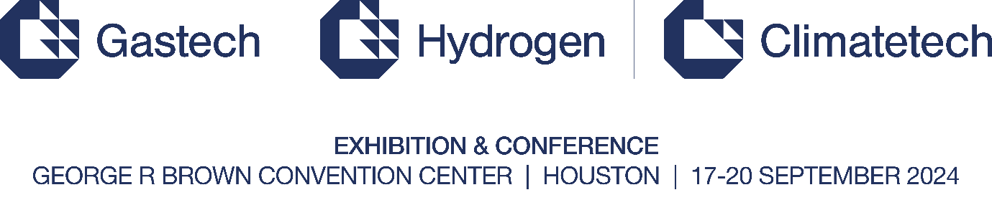

Gastech 2024 to Galvanize Global Energy Industry with Impact-Driven Strategic, Climatetech, and Hydrogen Conferences
- Gastech 2024’s Strategic Conference to host 500+ global business leaders, including CEOs and Energy Ministers, to transform and shape the future of energy.
- The Climatetech Conference will focus on accelerating strategies to decarbonize the energy value chain.
- The Hydrogen Conference will champion hydrogen’s role as a low carbon solution within the future energy mix.
HOUSTON, 14 May 2024 – Gastech, the world’s leading platform for natural gas, LNG, hydrogen, climate technologies, energy manufacturing, and low carbon solutions, has announced the theme for this year’s Strategic, Climatetech, and Hydrogen Conferences. Hosted in Houston, a global energy hub and the epicenter of the natural gas and LNG revolution, Gastech 2024 will lead industry-shaping discussions on the future of our energy system and the development of a new global industrial age.
Limiting global warming to 1.5°C requires reducing CO₂ emissions by nearly half by 2030 and achieving net zero emissions in the energy sector by 2050. Despite some progress, significant gaps remain between the current deployment of energy transition financing and technologies, and the levels needed to achieve the goal of the Paris Agreement. As it stands, the only way forward will necessitate a wholescale transformation of the way societies consume and produce energy.
Under the theme of “Transforming energy through vision, innovation and action”, Gastech 2024 will offer an invaluable platform for key stakeholders across the value chain to address these mounting challenges and align on a path to success. Serving as the framework for these efforts will be the Strategic Conference, structured around a set of principles and priorities integral to the industry’s future: Pioneering an equitable energy transition; Championing natural gas as an enabler of the energy transition; Mobilizing capital for a next-gen energy system; Forging a multi-source energy future through climate technologies; Elevating hydrogen's role in the global energy mix; Catalyzing partnerships, policy & regulation for sustainable impact; Cultivating talent for an evolving energy landscape.
Gastech 2024’s Strategic Conference will feature direct insights from the policymakers and business executives that are working to fulfill these essential goals, as they outline decisive strategies for advancing global energy transitions and economic growth. Across 4 engaging session formats - ministerial panels, global leadership panels, keynote addresses, and Energy Talks – the conference will drive critical conversations around the themes and topics that are defining the energy industry’s approach to long-term emissions reduction and operational sustainability.
Energy Talks, new for Gastech 2024, is a series of high-profile and in-depth interviews with industry CEOs and government officials. Led by renowned energy experts and broadcast anchors, Energy Talks sessions will enable delegates to understand the fast-changing dynamics of the world’s evolving energy needs.
The Climatetech Conference will explore cutting-edge technologies designed to reduce and mitigate global emissions, while providing a forum for energy leaders to discuss the cross-industry partnerships and initiatives that will ensure the commercial viability and scalability of such groundbreaking climate innovations.
The Hydrogen Conference will also pursue similarly significant outcomes, convening the industry’s leading players to unlock the full potential of hydrogen and discuss the challenges and opportunities of upscaling this promising energy solution.
Taking place nearly a year after the historic COP28, which saw 198 countries commit to the unprecedented UAE Consensus, Gastech 2024 will build on the ideas and projects that are driving the energy industry’s transition to net zero. Through high-level panel discussions focused on the central role of low carbon solutions and climate technologies industries, leading policymakers and business executives will reaffirm their commitment to the investments and regulation strategies needed to ensure global energy security, affordability, and sustainability.
Mark Menezes, President & CEO, United States Energy Association and Former United States Deputy Secretary of Energy, said:
"The upcoming Gastech Conference is the perfect setting for meaningful discussions and collaboration to drive progress toward a sustainable energy future. These events are key to finding innovative solutions for the evolving energy landscape."
Paul Everingham, CEO, Asia Natural Gas & Energy Association (ANGEA), commented:
“Gastech plays a very important role as a global forum that brings together nations, industry, and companies to work on meaningful, credible energy solutions. Our organization, the Asia Natural Gas & Energy Association (ANGEA), finds Gastech invaluable for facilitating discussions about the vital role that gas will play in enabling economic growth throughout Asia while also reducing carbon emissions.”

*Ends*

****

Notes to Editor
About Gastech
Taking place annually, Gastech stands as the world's foremost gathering for natural gas, LNG, hydrogen, climate technologies, energy manufacturing, and low carbon solutions. With attendance reaching more than 50,000 international participants, it serves as a pivotal platform where heads of state, government officials, ministers, global business leaders, disruptors, and innovators converge to engage in meaningful conversations on the future of global energy.
This year, Gastech will take place at George R Brown Convention Center in Houston, from 17-20 September 2024.
Media wishing to attend:
Contact us at marketing@gastechevent.com to be informed when media registration is open.
For more information, please visit www.gastechevent.com
Follow us on social media channels @Gastechevent and use #Gastech
For media enquiries, contact:
gastech24@pa.group / +44 75 3819 6545
For media partnerships, contact:
marketing@gastechevent.com / +44 77 1413 4683
About dmgevents
dmg events is one of the leading global event organizers, working across several key industries. Its energy portfolio includes some of the biggest events in the sector, such ADIPEC, the Global Energy Transition Congress, the Egypt Energy Show, the World Utilities Congress, and the Global Energy Show.
www.dmgevents.com

